REGISTRATION FORM OF 15th GCBSS CONFERENCE 2023

14 - 15 September 2023
NOVOTEL BANGKOK PLATINUM PRATUNAM, BANGKOK, THAILAND
(IN-PERSON & ONLINE)
http://gcbss.org /Registration-Payment.html

15th GCBSS will be held during 14 - 15 September 2023 at Novotel Bangkok Platinum Pratunam, Bangkok, Thailand (In-Person & Online). Please note that it is essential for all participants to email the filled Registration Form (.doc/.docx/pdf) along with Proof of payment receipt to ids: admin@gcbss.org and Cc to register@gatrenterprise.com

SECTION 1: CONTACT INFORMATION
Paper ID Code: For example, CIMSSR-00101
Name that you would like to get printed on the certificate:

Conference Title: 15th Global Conference on Business and Social Science, Bangkok, Thailand.
Whether attend the Conference: € Yes € No
Position (Professor/Associate Prof/Assistant Professor/Lecturer/PhD Student/Master Student/other):

Complete Affiliation/Organization/University and Country Name:
(That you like to get printed on the certificate)

Broad Field: i.e., Accounting |  | Are you willing to serve as a session chair:€ Yes € No
Session Type:€ Oral Presenter € Poster € 3 Minutes PhD proposal € Visual Presenter (ZOOM)
Telephone: | Mobile: |  | Email:
Special Needs or Dietary Requirements: € Yes €No
Fulltime Student ID Number of Your University (if applicable):
Abstract/Paper Title:
Paper Pages: |  | Additional Page:
Are you interested in joining Conference Tour: € Yes € No
Are you interested in attending GALA Dinner & Networking: € Yes € No
Are you interested in attending Workshop: € Yes € No
Are you interested in joining Academic Discussion Session: € Yes € No

Notes:
- One regular registration can cover a paper within 8 pages, including all figures, tables, and references at 1.5 line spacing. If the length exceeds 8 pages, the authors must pay USD 25.00 for each additional page.

- If the authors are more than two in the manuscript, authors are required to pay additional fees of USD 50 for each other author name.

- For additional Certificates, co-authors need to pay USD 100 for each other certificates.

SECTION 2: REGISTRATION FEES INFORMATION

15TH GCBSS FEE SCHEDULE: | Early bird  Until: 3/05/2023 | Normal  Until:  19/06/2023 | Late  Until: 06/09/2023
Oral/Poster Presenter (Lead Author) / Co-author | USD 525 | USD 575 | USD 600
Visual Presenter (Through ZOOM) | USD 425 | USD 475 | USD 500
Full-Time Student (Valid Student ID required) | USD 425 | USD 475 | USD 500
Additional Paper (by the same Presenter) | USD 300 | USD 325 | USD 350
Attendee (Without abstract/Paper) | USD 225 | USD 250 | USD 275
Online Attendee (Without abstract/Paper) (Through ZOOM) | USD 100 | USD 100 | USD 100
Additional Events for 15th GCBSS Delegates:
Academic Discussion Session on 14 September 2023 | FREE | FREE | FREE
GALA Dinner & Networking on 14 September 2023 | FREE | FREE | FREE
Workshop on Publishing in High Impact Factor (SSCI & SCI) Indexed Journals on 15 September 2023 (IN-PERSON & ONLINE) | FREE | FREE | FREE

GATR/GCBSS Policy:

- The lecturer cum student will not be considered for the student rate.
- A full-time student must submit a valid student ID card and letter of recommendation from the Dean.
- Daily Market Conversion Rate applies to all USD prices.
- Service/Transfer Fees are not included in the above prices.

Registration fee for Oral/Poster/ Student Presenter Included:

Admission to the welcome reception and all session

- Academic Discussion Session
- Conference KIT
- Printed presenter certificate with an official seal.
- Printed brief Program Schedule.
- Refereed Abstract Proceeding CD with ISBN
- Journal publication fees (Sponsored by GATR)
- Workshop on Publishing in ABS & ABDC indexed Journals.
- Two coffee breaks each day.
- International Buffet lunch daily
- GALA Dinner& Networking
- Free GCBSS Membership for 12 months.

Registration fee for Visual/Online Presenter Included:

Admission to the welcome reception and all session

- Conference KIT
- Printed presenter certificate with an official seal.
- Refereed Proceeding CD with ISBN
- Abstract Video publication on Official Channel
- Journal publication fees (Sponsored by GATR)
- Printed Program Schedule.
- Workshop on Publishing in ABS & ABDC indexed Journals.
- Free GCBSS Membership for 12 months.

Registration fee of Attendee Included:

Admission to all session

- Participation Certificate with an official seal
- Refereed Proceeding CD with ISBN
- Program Schedule
- Workshop on Publishing in ABS & ABDC indexed Journals.
- Free GCBSS Membership for 12 months.

SECTION 3: PAYMENT INFORMATION

OPTION 1

Bank Deposit / ATM Transfer / Online Transfer / Telegraphic Transfer in Company’s official account.

Please Visit http://gcbss.org/Registration-Payment.html.
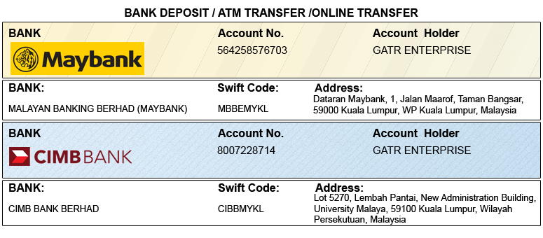

OPTION 2

Credit Card /Debit Card/PayPal/2Checkout Account to GATR 2checkout official account. Registered email: info@gatrenterprise.com

Please visit http://gcbss.org/Registration-Payment.html.

Note: Please mention your Abstract Id in particulars to trace your payment. 5% Transaction Charges will be applied for payment through credit card.

PRIVACY POLICY:

The Global Academy of Training & Research (GATR) Division will protect your personal information. Your personal information received will only be used to fill your order, and we will not sell or redistribute your information to anyone.

CANCELLATION POLICY:

You may cancel without penalty if the written cancellation request is received up to and including 45 days before the start of the conference. A credit voucher for less than 50% of the registration fee will be issued for written requests received up to and including 25 days before the start of the conference. No refunds or credits will be published on cancellation requests received less than 25 days before the beginning of the event. No liability is assumed by Global Conference on Business and Social Science for changes in program, date, content, speakers, or venue.

PLEASE NOTE: Original receipts will be emailed to register guests before the conference for claim purposes.

Declaration: I agree that I cannot claim back the registration fee I paid under any circumstance.
SIGNED:  (or write your name here) |  | DATE:

